St Peter & St Paul, Black Notley

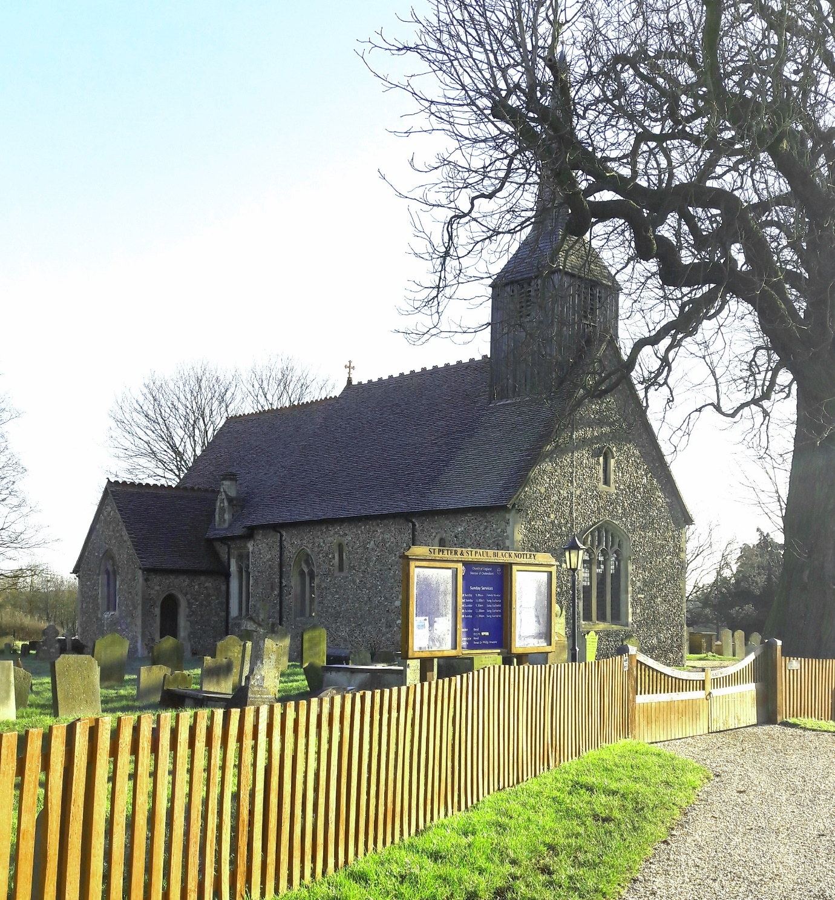

Churchyard Guidelines

Introduction
Coming to terms with the death of someone you loved or for whom you were responsible is inevitably painful and difficult. And for those who were closest to the person who died, there are also numerous practical tasks to be attended to, many of which are not at all straightforward. The business of selecting a place in which to bury the body or the ashes, and in due course deciding what headstone to put up and what it should say – all this, too, can be a source of anxiety and distress. But it can be part of that process of coming to terms with it all, of saying good-bye and moving forward. Once the body or ashes have been buried, you will sooner or later have to choose a headstone or other memorial of some kind. This too is not an easy matter – not least because it can re-open old wounds – but it is important to get it right.
The Parochial Church Council (PCC) have produced this leaflet to help make you aware of the rules regarding graves in our churchyard and to help you understand them at this difficult and sensitive time.
We aim to:
- enable families to tend the graves of loved ones in ways which help their grief and love
- allow good access for mowers so that we can more easily keep the churchyard tidy
- ensure the churchyard is in keeping with its natural setting
- keep the churchyard clear of items that can, if broken, be hazardous to walkers or mowers
St Peter and St Paul’s Churchyard
The English churchyard is a place of quiet and repose, a place where comfort is drawn from the peace provided by being close to God and to his church. The setting of our churchyard here, overlooking local farmland and village fields, is particularly beautiful and inspiring.
Our churchyard comes under the jurisdiction of the Chancellor of the Diocese of Chelmsford and graves in this churchyard have to comply with the regulations published in the Diocesan Churchyard Handbook.
Memorials
Since the churchyard is consecrated ground, there are restrictions on the wording and memorials allowed for those buried here. In addition, materials need to be in keeping with the historic nature of the building and the natural environment. Control of the churchyard and suitability of memorials rests ultimately with the Diocesan Chancellor. The local Priest is allowed to give permission only for the memorials which fall within the guidelines; anything unusual will need to be referred to the Diocese for special permission (called a ‘Faculty’).
When you come to consider a memorial, your Funeral Director or local Stonemason should be able to advise you on what is possible. No applications should be made for the introduction of a memorial until at least six months after the burial.
Full details of the kinds of text, headstones and decorative inscriptions that are permitted are available in The Churchyard Handbook on the Chelmsford Diocesan website, and you can find the details at the end of this leaflet. If a memorial or headstone of any kind is desired, then application in the first instance is made on a CR1 form which is supplied by your Funeral Director or Stonemason, and then sent to the Rector for approval.
Please note that over the years guidelines have changed, and so what you see on a neighbouring gravestone may no longer be permitted or may require special permission from the Diocese.
Flowers
One flower vase may be set in the headstone base, but other containers are not allowed as they may become a health and safety hazard if broken. Any special requests will require a Diocesan Faculty application and should be discussed with the Rector before proceeding.
Only fresh flowers should be used, as the churchyard is set aside to be a holy place in which flowers and plants grow naturally, in keeping with the seasons. Plastic or artificial flowers of any kind are not permitted, though there are three limited exceptions: poppies on Remembrance Sunday; wreaths at Christmas and wreaths at the anniversary of the death of the deceased, for a limited period of two weeks.

Planting
Our choice is for graves to be turfed. We recognise, however, that many families prefer to use plants and bulbs to enhance their graves. The size of the planting area should not exceed 190cm by 75cm (6ft 3ins by 2ft 6ins) including the headstone. Please note that shrubs are no longer permitted and the use of weed killer or fertiliser of any kind is prohibited.
Surrounds
The Diocese of Chelmsford no longer permits any kind of fencing, edging or any other artificial enclosure of any kind around a grave or the use of chippings or other stones on the grave as they are a hazard for mowing equipment and can cause damage if thrown by vandals.
Ornaments
We are aware that there are now many kinds of ornaments on sale by which to remember loved ones. Whilst these may be helpful to individuals, we do not encourage their placement in the churchyard since the main memorial for churchyard graves is a headstone.
Cremated Remains

There is an area in our churchyard for the interment of cremated remains. It is enclosed on three sides by memorial walls; any additions to these walls must be made by Atstone Memorials, Braintree. Ideally the cremated remains should be interred directly into the ground without any container and this practice is encouraged. If any container is used it must be completely biodegradable. According to the canon law of the Church of England it is the duty of the minister to bury cremated remains, so they may not be scattered on the surface of the churchyard.

Wild Areas
We want to encourage biodiversity in our churchyard. As such, areas of the churchyard will remain uncut to encourage rewilding.
Rubbish
Ongoing maintenance of the churchyard rests with the volunteer members of the church. We politely request that all dead flowers and any other rubbish is taken away after you have tended a grave.

Finally
We recognise that the care of individual graves and the churchyard as a whole is a very sensitive issue. In compiling these guidelines, we have tried to recognise the needs of bereaved families and friends and to keep in step with the regulations set by the Diocese of Chelmsford. We will make every effort to enable families and friends to find helpful and meaningful ways of commemorating their loved ones, within what we are legally permitted as churchyard trustees.

Further Details
We strongly urge you to look at the Churchyard Handbook published by the Diocese of Chelmsford before making any plans. This can be found on the Diocesan website:
www.chelmsford.anglican.org/uploads/dac-docs/Churchyard_Handbook_March_2020_Edition.pdf
A printed copy may be obtained through the Diocesan Office: telephone 01245 294400

Rector Revd Rachel Prior 01376 325277
Churchwardens Nettie Sibree-Lait 07973 820867
Mrs Marion Morrison 01376 349619

