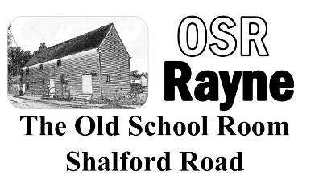 | HORTICULTURAL AND CRAFTS SHOW
Saturday 19th September 2026
ENTRY FORM
Entry Rules:
Each exhibitor MUST list all the classes they are entering on a single entry form to be completed by and returned, together with 50p for each entry by 6pm on Wednesday 16th September 2026, to Andy Goldsmith, 11 The Maltings, Rayne or Joy Darby 33 Smiths Field, Rayne
or to the Old School Room between 6pm and 8pm on Wednesday 16th September 2026 when the committee will be there to receive them.

SORRY—NO LATE ENTRIES CAN BE ACCEPTED AS WE WILL BE PREPARING THE ENTRY LISTS READY FOR JUDGING AS SOON AS THE OLD SCHOOL ROOM CLOSES ON THE 16th

NAME: | Tel.No:
Address (incl. postcode) | Email:
 | Age & school year if entering children’s classes
If you do not live in a Rayne postcode, please name the village organisation you are a member of: | Parent’s signature for consent to enter if exhibitor is a child:
I have read the rules and understand them and agree to comply with them (Parent or guardian to sign if exhibitor is a child under 16)

Signature and date:

Number of classes entered (only one entry per class) |  | Entry fees enclosed (50p per class except free children’s classes)
EXHIBITOR NUMBER (to be entered by OSR Committee) |  | Please tick if you would like to receive information on a future show if we decide to run one
This information will not be shared with any 3rd party

Contact details for the OSR Show committee:
Show Secretary: Andy Goldsmith: e-mail: andyjgoldsmith@googlemail.com Tel: 07818 498590
Joy Darby: e-mail: Joy.darby@hotmail.com Telephone: 07702 632021
Colin Miles: e-mail: crmiles@sky.com Telephone: 07775 756009

For full details of each class, please read the show schedule to ensure your entry complies

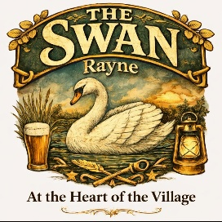 | Thank you to our show sponsors at  The Swan, Rayne | 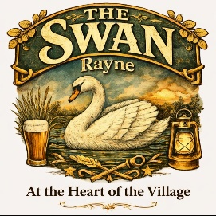
Please tick all classes you wish to enter and tick any entries you will allow us to sell after the show.

SECTION 1 HORTICULTURE |  | enter | sell |  | SECTION 4 HOMECRAFT | enter | sell
101 | 6 runner beans |  |  | 401 | A Victoria sponge
102 | 6 French beans |  |  | 402 | A Lemon drizzle cake
103 | 3 round beetroot |  |  | 403 | 4 chocolate brownies
104 | 1 butternut squash |  |  | 404 | 4 decorated cup cakes
105 | 4 carrots |  |  | 405 | 4 flapjacks
106 | 2 courgettes – flowers attached |  |  | 406 | 4 plain scones
107 | 1 cucumber indoor grown |  |  | 407 | An apple pie
108 | 4 onions |  |  | 408 | 1 jar strawberry jam
109 | 4 potatoes |  |  | 409 | 1 jar jam—any other type
110 | Any other vegetable |  |  | 410 | 1 jar marmalade
111 | 1 truss of small tomatoes |  |  | 411 | 1 jar chutney or pickle
112 | 6 tomatoes
113 | 5 dessert apples |  |  |  | SECTION 5 ART & CRAFT
114 | 5 cooking apples |  |  | 501 | A container made from fabric
115 | Any other fruit |  |  | 502 | A decorated pebble 15cm
116 | Heaviest marrow |  |  | 503 | An embroidered picture
117 | Longest runner bean |  |  | 504 | A greetings card
 |  |  |  | 505 | A handicraft item (wood/metal)
 | SECTION 2 FLOWERS |  |  | 506 | A hand knitted or crocheted item
201 | Asters, 6 blooms, mixed |  |  | 507 | A stitched item
202 | Chrysanthemum - single bloom
203 | Spray chrysanthemums |  |  |  | SECTION 6 - CHILDREN
204 | Dahlias (cactus or decorative) |  |  |  | pre-school years
205 | Dahlias (ball or pompom) |  |  | 601 | A garden on a plate
206 | Dahlias, 3 blooms, mixed |  |  | 602 | A decorated pebble or stone
207 | Roses, floribunda - 3 blooms |  |  | 603 | Finger painting
208 | Rose Hybrid Tea – 1 bloom
209 | Vase of 5 cut flowers, one variety |  |  |  | school years 1 to 3
210 | Vase of 5 cut flowers, 5 mixed |  |  | 611 | A garden on a plate
211 | Pot plant - a cactus or succulent |  |  | 612 | A decorated pebble or stone
212 | Pot plant - foliage |  |  | 613 | An animal made from vegetables
213 | Pot plant - flower
 |  |  |  |  | school years 4 to 6
 | SECTION 3 FLORAL ART |  |  | 621 | A garden on a plate
301 | ‘Wax Lyrical’ |  |  | 622 | A decorated pebble or stone
302 | Hand tied posy |  |  | 623 | A painting or drawing of a swan
303 | Miniature arrangement
304 | Arrangement in a Wellington Boot |  |  |  | school years 7 to 9
 |  |  |  | 631 | A garden on a plate
 |  |  |  | 632 | A decorated pebble or stone
 |  |  |  | 633 | A painting or drawing of a swan

AND FINALLY…… A POETRY SECTION OPEN TO EVERYBODY (FREE TO ENTER)
701 | A limerick starting with the line: 'I entered the Old School Room show'

After the show, we plan to publish a list of the winners’ names (1st, 2nd, 3rd & Highly Commended).
If you do not wish to have your name published, please tick here:

